# DATABASE SYSTEMS

# Hassaan Akbar Cheema

# Reg no. 174351

# Bscs6c

# Lab 06

**Task: Write SQL expressions using Join Operator for each of the following queries and execute them:**

1. Find the names of faculty members that has taught classes only in room R128.

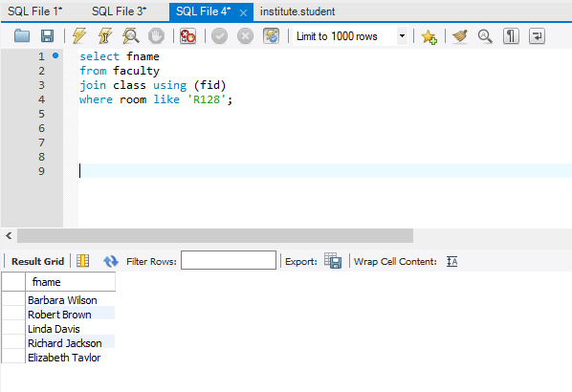

1. Find the names of classes taught by ‘Richard Jackson’ and their times when a class meet there.

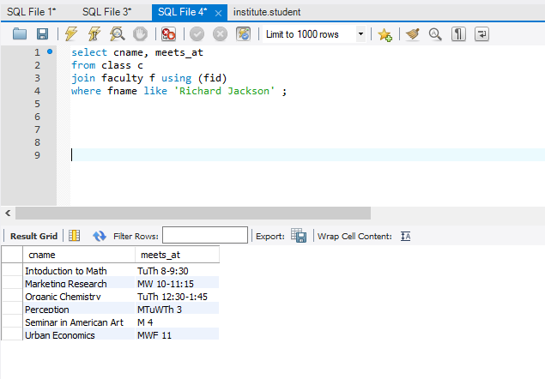

1. Find the names of classes taught by ‘John Williams’ in dept # 68.

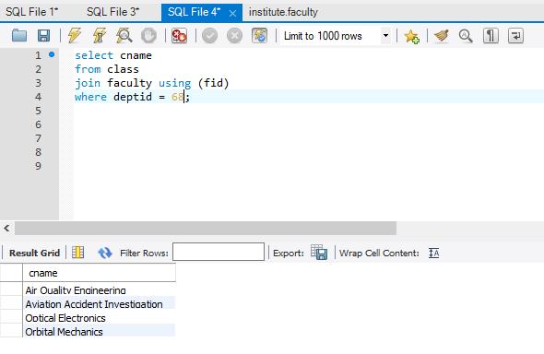

1. For each class taught by ‘John Williams’, retrieve the name and age for students.

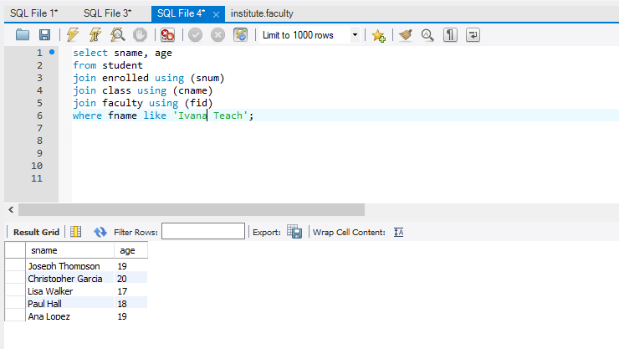

1. Find the names of faculty that teach ‘Database Systems’ class in descending deptid-wise.

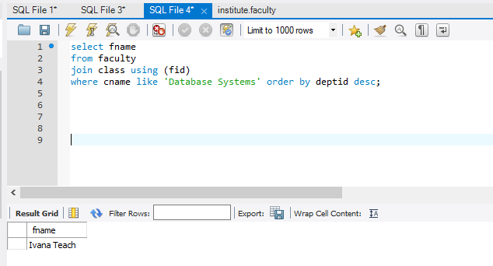

1. Find distinct student ages in ‘Database Systems’ class in descending order.

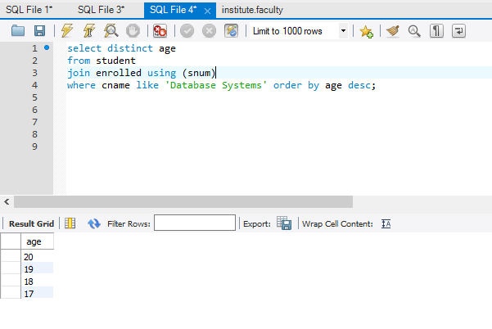

1. List the name of ‘Christopher Garcia’s teachers.

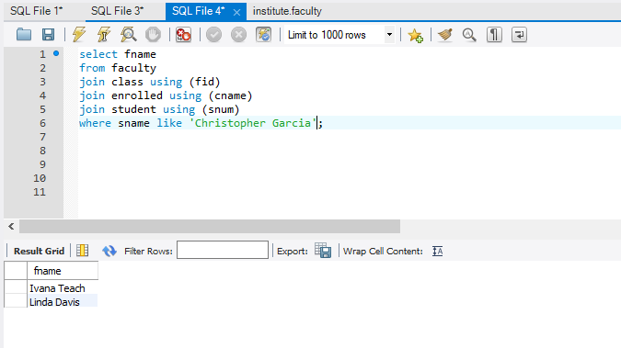

1. Find the name and age of student in ‘Database Systems’ class.

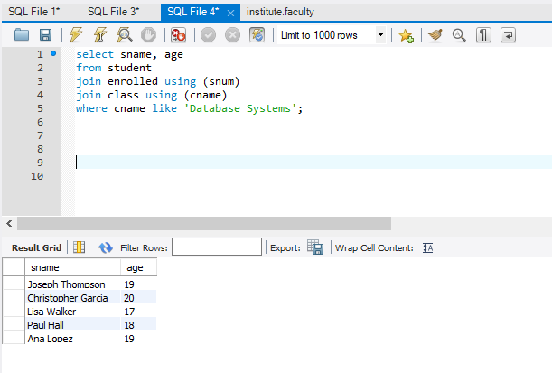

1. Find the class names, strength of faculty members for each class.

